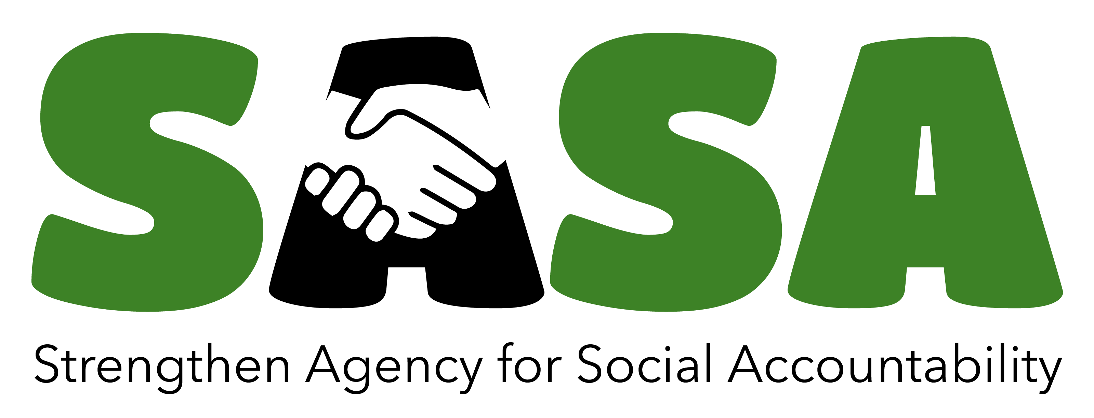
APPLICATION FORM

Grant Programme

 | Partner details
Applicant organisation: |  | Contact person
Address: |  | Address if different from organisation’s address:
Telephone: |  | Telephone/mobile phone:
Skype (if applicable) |  | Skype (if applicable)
E-mail: |  | E-mail:
Home site:
Registration number:

We would like the correspondence concerning the application is made to

Specify (Phone Number, Designation, e-mail/skype)

Application must be signed by two authorised signatories

Place and Date | Place and Date
Signature authorised signatory 1 | Signature authorised signatory 2
Name | Name

Project Summary

Project No.
(Filled in consultation with ForumCiv)
Title of intervention/project
Counties of Operation
Date of submission
Planned intervention period
Total budget in SEK

Application Guide;
The instructions in each section below clarify ForumCiv’s expectations. We have divided the template into the following sections:
- Executive summary (max 1 page)
- Introduction (max 1 page)
- Context analysis (max 2 page)
- Problem statement (max 1 page)
- Intervention (max 4 pages)
- Financial summary and control (max 1 page)
- Annexes
- Signature
Keep the application short. Maximum of 10 pages

EXECUTIVE SUMMARY

Remove this box before submitting the application
Executive summary (maximum 1 page)

Write a short summary or outline of your intervention. Include your problem statement and intervention strategy in short as well as the intended results at outcome-level. Also include how your intervention has a rights based approach and how it contributes to the programme result areas annexed to this document.

INTRODUCTION

Remove this box before submitting the application
Introduction (maximum 1 page)

This part of the application should give a brief about your organisation, its priorities, strengths, geographical coverage, previous experience and achievements.
Describe how you have applied a rights-based approach when designing the intervention specifically the principles of participation, non-discrimination, accountability and transparency.
Describe the lessons learnt from previous interventions and how they have helped shape this intervention.

CONTEXT ANALYSIS

Remove this box before submitting the application
Context analysis (maximum 2 page)

This part of the application should describe and analyse the context-specific conditions that exist prior to the intervention. This includes mapping out existing strengths and capabilities, challenges and risk factors the target area, as well as relevant actors and motivate why the intervention is needed.
Take previous experiences, research and/or available data into account. Include an analysis of important issues, trends and actors in the context. The analysis should relate to the development challenge you have identified and its causes.
Make clear links to the problem statement and development goal in the next section, to motivate your strategies and the design of the intervention.
General information of the country and counties should only be included if it is relevant to understand the problem statement or development goal and its causes.

PROBLEM STATEMENT

Remove this box before submitting the application
Problem statement and development goal (maximum 1 page)

This section should provide a description of the specific challenge that you have identified, its most significant causes.
This section should also reflect on the cross-cutting issues namely human rights-based approach, gender, conflict and do not harm; environment and climate change where applicable

INTERVENTION

Remove this box before submitting the application
Intervention (maximum 4 pages)

This section should provide a presentation of the proposed intervention. The section should include an explanation of how the intervention will contribute to the development goal. What methods and key activities will you use to achieve this? Include an analysis of actors and power and describe how the intervention will contribute to the organisation and mobilisation of rights-holders, the strengthening of the civil society, and to duty-bearers being motivated and able to fulfil their obligations.

The headings below are a suggested structure.
Project Goal
- It should present the overall development goal and desired change of the intervention. It should also show how these relate to your identity and experience as applying partners.
Project Outcomes
- Clearly outline the desired results of your project. We will be keen to see how it fits to the Programme goal and result areas annexed here; and how it fits in your organizational strategic direction
Social Actors (direct and indirect target groups)
- Describe the social actors your intervention will seek to engage/change. Include the duty bearers and the rights holders. State total number of the direct and indirect participants

Your reflections of the Project Outcomes to the Social Actors should be guided by the table below.
Social Actor | Expect to see | Like to see | Love to see

Implementation, monitoring, evaluation and learning
- Describe your organisational capacity for implementation and how you will apply the rights-based approach in your intervention
- Describe the Monitoring, Evaluation and Learning (MEL) plan, your routines and processes. In specific: How will you monitor and follow up on the outputs and outcomes? How will you integrate gender perspectives in MEL? How will you use monitoring to learn and adapt the implementation continuously (adaptive management)? How is the baseline done by ForumCiv used in your planning and MEL?
- Detail any capacity development gaps/need you have identified and how will you address them in the intervention?

Sustainability:
- Describe how the intervention will contribute towards sustainable results for people and communities as well as on a system or society level, during and after the intervention.

FINANCIAL SUMMARY AND CONTROL

Remove this box before submitting the application
Financial summary and control (maximum 1 pages)

This section should provide a comprehensive description and justification of the intervention budget. Include a description of what capacity and systems are in place for quality assurance, budget and financial control (when applicable, refer to policies, routines and mechanisms). It should also include an analysis of cost effectiveness.

Also include a summary of the budget in SEK and KES in line with the main budget lines provided in a table format.

ANNEX
Remove this box before submitting the application
Annexes

Provide an index of the documents or documentation attached to the application. Below you find a list of annexes required for all applications. Please note that others may be required based on the focus, scope and nature of your intervention.

Required annexes
- Detailed budget
- Risk assessment
- Outcome Journal
- Job descriptions for staff/volunteers
- Anti-corruption policy

Other annexes
Additionally, kindly provide the following formality and complement documents to the narrative application;
- Work plan or plan of activities
- Procurement policy or equivalent
- List of Bank signatories
- Strategic plan (where applicable)
- Other relevant annexes referred to in your applicatio

SIGNATURE

Authorised representatives from the partner organisation are to sign this application.

Date: | Date:
___________________________________________ | ________________________________________
Signatory | Signatory
___________________________________________ | ________________________________________
Name in block letters and position | Name in block letters and position

